|  |  |  |  |  |  |
| --- | --- | --- | --- | --- | --- |
| 班級： |  | 座號： |  | 姓名： |  |

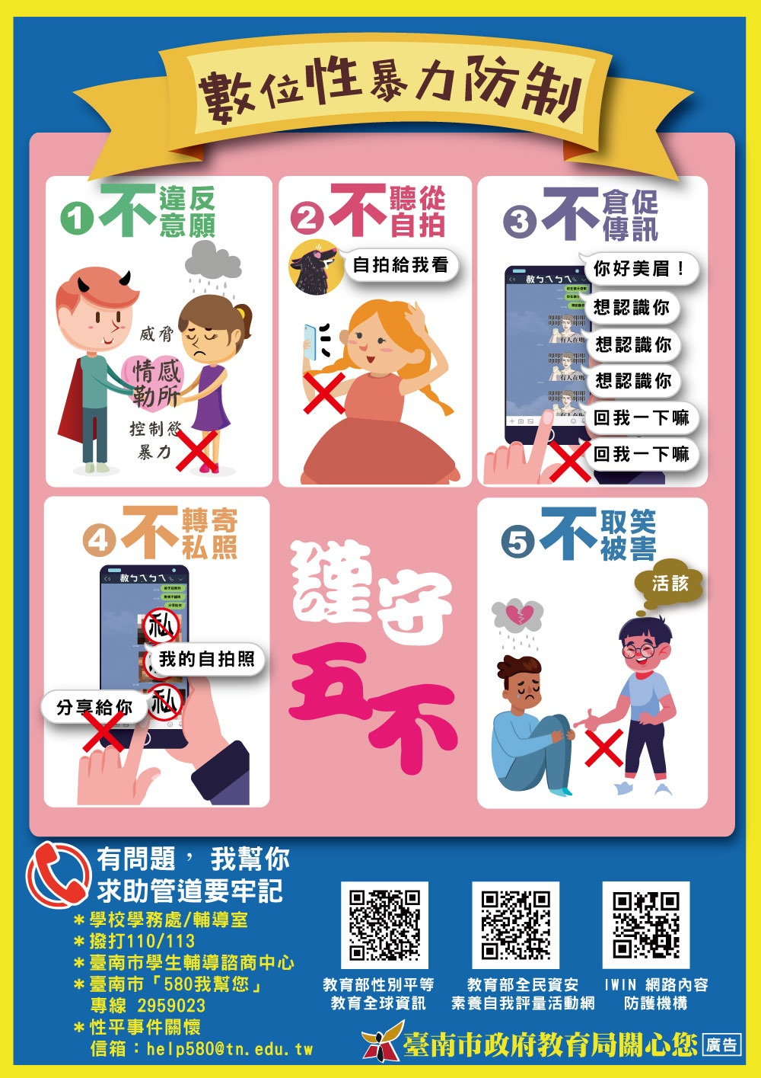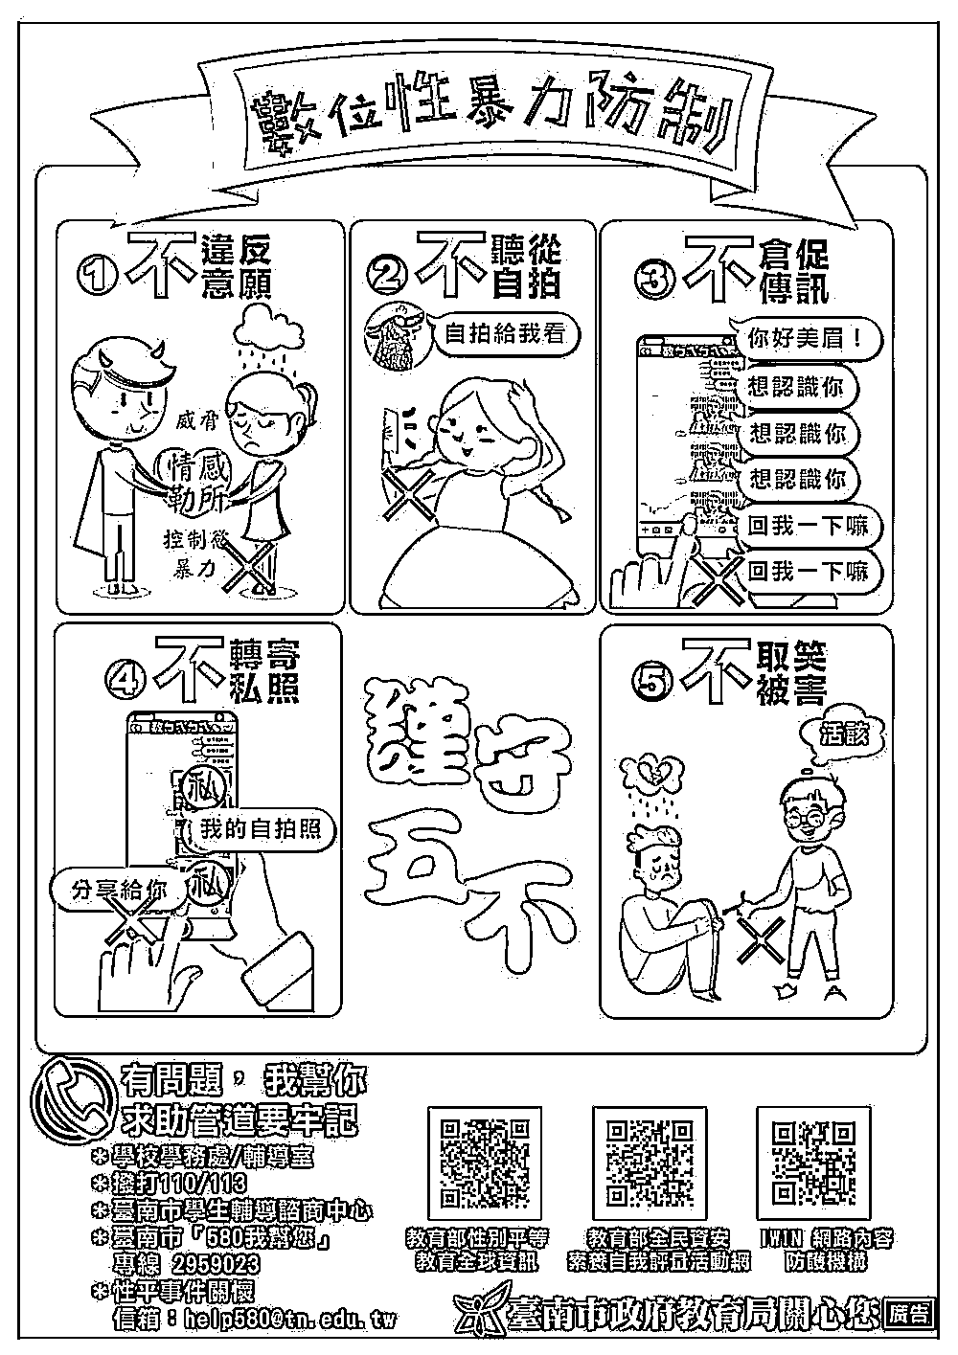

**113/6/3前完成並交回輔導室**